Final Report

SEPARATIONS IN BIOPROCESSING

Kathryn Atherton

Bioprocess Engineering Laboratory

Agricultural & Biological Engineering

West Lafayette, IN 47906

April 6, 2018

***Summary***

Xanthan gum is a useful substance for a variety of industrial biological processes. However, in order to be useful for industrial processing, it must be pure. As xanthan gum can only be produced through fermentation of *Xanthomonas campestris,* purification through solution separation must be performed. To do so, membrane filtration is done to separate the xanthan gum based on its size from the rest of the fermentation broth. Ultrafiltration using a membrane with a pore size smaller than that of xanthan gum performs the separation task.

The selectivity of a membrane is calculated by dividing the difference of the retentate and permeate xanthan concentrations by the retentate concentration. The efficiency, or volumetric flux, of the membrane can be calculated either experimentally, using the pressure of the system and the area of the membrane, or empirically, using the transmembrane pressure, xanthan concentration of the permeate, and the pumping flow rate.

The membrane filtration apparatus was tested by measuring the permeate feed flow rate and the concentration of xanthan gum in the permeate and retentate feeds while varying the transmembrane pressure and pump flow rate. The data was used to calculate the retention coefficient and the volumetric flux of the membrane.

It was expected that the retention coefficient would fall somewhere between zero and one. [Did this happen? What was the value? If not, why?].

In calculating the volumetric flux of the membrane with experimental values, values found were [. Comment on trends, reasons for them.]. The transmembrane pressure was graphed against the permeate fluxes calculated and it was determined that the membrane is in the [pressure/mass-transfer controlled region for what values? Why? Is that expected?]

In literature, the filtrate flux constants were found to be [a,b,c]. By finding the constants graphically, they were found to be [a,b,c]. [Comment on differences, reasons].

As retentate was not captured for high transmembrane pressures, it is recommended that for future use of the apparatus low pressures be used in order to capture the desired xanthan gum product. [more recommendations]

***Introduction***

For industrial processes, xanthan gum is typically required in a pure form. However, it can only be produced by the bacteria *Xanthomonas campestris* through fermentation. As such, it is rarely found in the pure form as *X. campestris* must produce many other products for survival. To make the fermented xanthan gum useful, the it must be separated as completely as possible from the other biological products while maintaining its properties. To do so, a bioseparations process is used. Xanthan gum, a particle of 500 kDa size, is separated from its fermentation broth using ultrafiltration, assuming other larger particles have already been separated. Ultrafiltration uses a pore size of ten to 1000 nanometers (Giwa, 2012). In using the ultrafiltration process, the xanthan gum is found in the retentate, or the part of the original solution that is unable to pass through the membrane.

***Theory/Basic Principles***

To isolate a target substance, materials are separated based on size, charge, reactivity to other substances, and phase change at different temperatures, among other methods. It is very rare to perform a one-step separation. As such, one must plan the best order of steps to most efficiently purify the substance of interest. Solid particles are usually separated first using size; the largest particles are removed before smaller ones before potentially using another method to further purify the desired material (Doran, 1995).

Membrane filtration is a method of bioseparations which separates solid particles from a liquid solution. A membrane is a thin barrier which allows selected materials to pass through. These materials become the permeate. The size of the filter pores determines what size of particles are separated from the mixture. Dissolved particles larger than the filter pores are stopped while the liquid and any smaller particles continue through the membrane (Doran, 1995). The materials that are filtered out and remain on the other side of the barrier are the retentate. Membrane pores can separate particles of macro size to ion size (Giwa, 2012).

The selectivity of a membrane filter is described by the retention coefficient, R (Equation 1). Theoretically, the retentate has a higher concentration of xanthan gum than the original feed or the permeate. As such, the retention coefficient varies from zero to one.

|  |  |  |
| --- | --- | --- |
|  | $$R= \frac{C_{R}-C_{P}}{C_{R}}$$ | [1] |

The volumetric flux, the rate at which particles pass through the membrane, determines the precision of the separation process. Volumetric flux, or the efficiency of the membrane, depends on the volumetric flow rate across the membrane and the area of the membrane across which mass flows, as described by Equation 2. Flux is directly correlated to the pressure of the system at low pressures, meaning that the system is pressure-controlled, but at higher pressures, the flux is not related to pressure, meaning that the system is mass-transfer controlled (Doran, 2013).

|  |  |  |
| --- | --- | --- |
|  | $$J_{V}= \frac{F_{P}}{A}$$ | [2] |

Flux can also be calculated empirically with Equation 3. The constants a, b, and c can be found using logarithmic plots of transmembrane pressure, xanthan concentration in the permeate, pumping flow rate, and volumetric flux (Lo, et. al., 1996). The equation can predict the flux for varying xanthan concentrations, pumping flow rates, and transmembrane pressures.

|  |  |  |
| --- | --- | --- |
|  | $$J_{V}= 3.51∙{10}^{-5}ΔP^{a}C_{P}^{b}Q^{C}$$ | [3] |

***Experimental***  
 The volumetric flow rate of the pump was first calibrated to different pump settings by timing how long the pipe took to fill a graduated cylinder to a certain volume. Concurrently, the spectrophotometer was calibrated to determine the absorbance readings range at 325 nm for a xanthan gum solution between concentrations of 0 g/L and 0.1 g/L. These two steps allowed for consistency in readings taken throughout the rest of the procedure.

Transmembrane pressures of 2, 4, 6, 8, and 10 psi were tested by the membrane filtration apparatus, shown in Figure 1, at four different pump flow rates, settings of 4, 6, 8, and 10. For each test, a 1 mL sample of the permeate and retentate was taken and the permeate flow rate was measured. Each retentate sample was then diluted 20x, 1mL of the sample was mixed with 3 mL of sulfuric acid, and the absorbance at 325 nm was measured with the spectrophotometer. It was ensured that all spectrophotometer readings fell within the range found during the calibration steps.

***Presentation and Discussion of Results***

The calibration data was first converted to find the pump flow rates for each pump setting and to create the calibration curve for the spectrophotometer readings of the xanthan gum solution absorbances. Table 2 shows the results of the pump flow rate calculation (Sample Calculations #1) and Table 3 shows the results of converting the solution absorbance values to concentrations using the calibration curve shown in Figure 4.

Equation 1 was used to calculate the retention coefficient. Unfortunately, as most of the retentate samples yielded little to no liquid volume, most of the data was unusable; of the 40 data points, only eight produced usable results while the rest either did not yield a sample or had a retentate concentration value of zero, making the retention coefficient undefined. The average value of the retention coefficient for the membrane used was 0.97 ± 0.025, meaning that the membrane performed nearly perfectly, keeping about 97% of the xanthan gum out of the permeate feed. See Table 4 for the specific data points used.

Using the time taken by the filter apparatus to fill a specific volume of permeate feed, the permeate flow rate was calculated. This value was divided by the area of the membrane to obtain the permeate flux of the membrane for each data point. Average values of the permeate flow rate and flux for each transmembrane pressure can be found in Table 5. The transmembrane pressure was graphed against the permeate flux, as seen in Figure 2. In a pressure-controlled filtration region, the flux will increase exponentially with an increase in pressure whereas in a mass-transfer-controlled filtration region, the flux will have a linear or no correlation with the pressure (Doran, 2013). As it appears that Figure 2 fits into the second category, it can be concluded that the membrane is in the mass-transfer-controlled region.

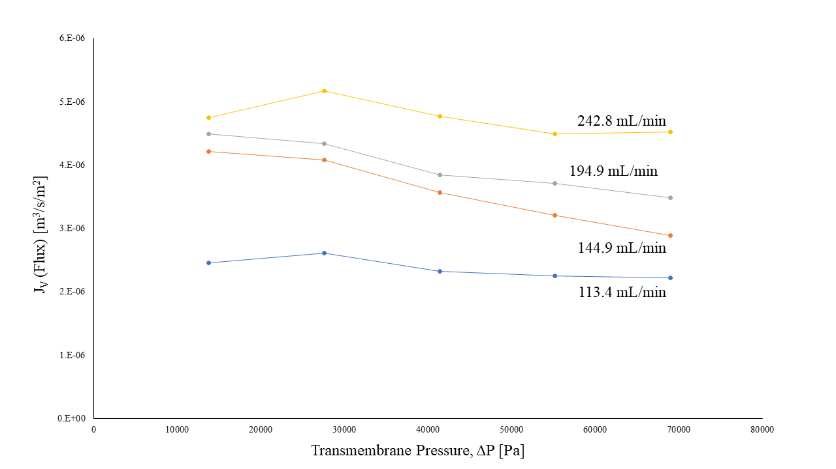

**Figure 2:** Plot of flux vs. transmembrane pressure varied across average volumetric flow rate. It can be seen that as transmembrane pressure increases, flux generally decreases and as volumetric flow rate increases, flux also increases. The decreasing correlation between the flux and pressure shows that the membrane is in the mass-transfer-controlled region.

In order to determine the empirical constants for Equation 3 to find the filtrate flux, logarithmic plots of JV vs. ΔP, CP, and Q were created (Figure 3). The constants were calculated from the slope of the linear trendline formed by the data. Equation 4 shows the experimental results of finding the empirical constants and Equation 5 is a mathematical model for filtrate flux from literature (Lo, et. al., 1996).

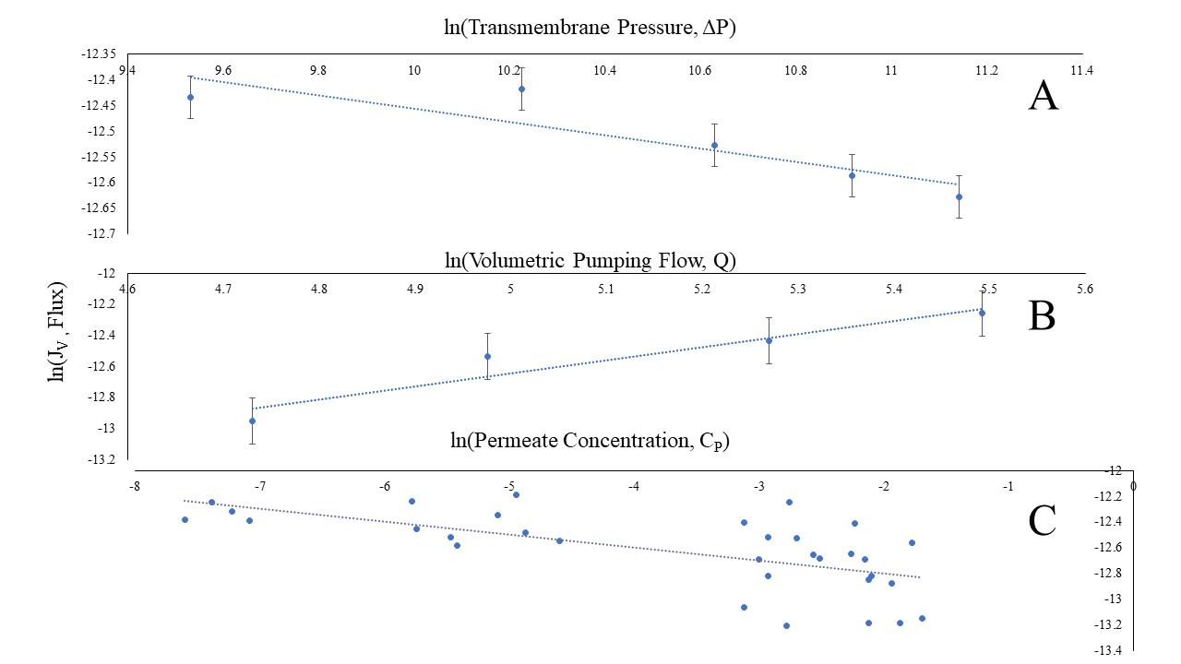

**Figure 3:** Plots of the natural log of flux against the natural log of transmembrane pressure, volumetric pumping flow, and permeate concentration. The slopes of the trendlines are the exponent of each respective variable in Equation 3 and the equation yielded by the above results can be found in Equation 4. The slope of the pressure plot was -0.13, the slope of the pumping flow plot was 0.84, and the slope of the permeate concentration was -0.10.

|  |  |  |  |  |
| --- | --- | --- | --- | --- |
|  | $$J_{V}= 3.51∙{10}^{-5}ΔP^{-0.13}C_{P}^{-0.10}Q^{0.84}$$ | | | [4] |
|  | | $$J_{V}= 3.51∙{10}^{-5}ΔP^{0.25}C_{P}^{-0.64}Q^{0.32}$$ | [5] | |

As none of the coefficients in either Equation 4 or 5 have an absolute value of one, none of the variables in the empirical flux equation have a linear relationship with flux. The most apparent difference between the experimental equation, Equation 4, and the literature equation, Equation 5, is that the pressure variable exponent in Equation 4 is negative while it is positive in Equation 5. The difference between these coefficients may be due to the membrane only being tested across the mass-transfer control region for the coefficient for Equation 4, where the pressure does not have a positive correlation with flux. The other two coefficients also have major differences between their values. Only 40 data points total were used to find the coefficients of Equation 4, which may have been a cause for seeing the large differences in the data. As more data points are used (e.g. more volumetric flow rates and transmembrane pressures), the data will converge to become more accurate and closer to the equation found in literature.

***Conclusions and Recommendations***

***Nomenclature***

***Appendices***

**Appendix A: Figures and Tables**

**Table 2:** Converting pump setting numbers to volumetric flow rates. The time for the pump to fill a graduated cylinder to the 10mL level was recorded for four different settings. The volume was divided by the time and then the volumetric flow rates were averaged and converted from mL/s to mL/min (Starred value was found in Sample Calculations #1).

|  |  |  |  |  |
| --- | --- | --- | --- | --- |
| **Pump Setting [-]** | **Time [s]** | **Volume [mL]** | **Volumetric Flow Rate [mL/s]** | **Average Volumetric Flow Rate [mL/min]** |
| 4 | 5.54 | 10 | 1.81 | 116.9* |
| 4 | 4.97 | 10 | 2.01 |
| 4 | 5.06 | 10 | 1.98 |
| 6 | 4.07 | 10 | 2.46 | 141.6 |
| 6 | 4.29 | 10 | 2.33 |
| 6 | 4.36 | 10 | 2.29 |
| 8 | 3.02 | 10 | 3.31 | 193.0 |
| 8 | 2.98 | 10 | 3.36 |
| 8 | 3.35 | 10 | 2.99 |
| 10 | 2.27 | 10 | 4.41 | 249.8 |
| 10 | 2.53 | 10 | 3.95 |
| 10 | 2.42 | 10 | 4.13 |

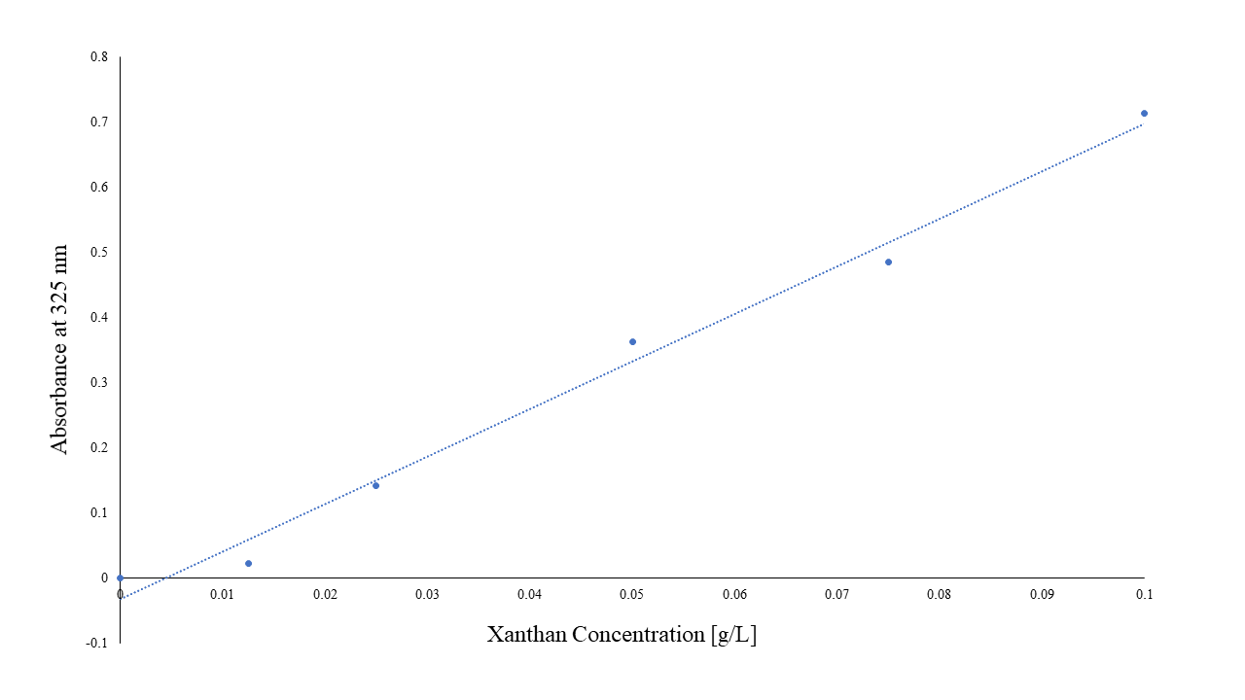

**Figure 2:** Calibration curve of absorbance values vs. concentration values. The linear curve has an equation of (Absorbance at 325 nm) = 7.3112 * (Xanthan Concentration) - 0.0322 with an R² value of 0.9889. The linear curve was used to convert the absorbance values of the retentate and permeate samples to concentrations.

**Table 3:** Converting absorbance values from the permeate and retentate feed samples to concentration values. The calibration curve from Figure 2 was used to convert the absorbance to concentration and then the retentate concentration values were multiplied by 20 to account for the 20x dilution made for the retentate samples to ensure that spectrophotometer readings would fall within the calibration curve range (Starred values were found in Sample Calculations #2).

|  |  |  |  |  |  |
| --- | --- | --- | --- | --- | --- |
| **Pump setting [-]** | **Pressure [Pa]** | **Retentate OD [absorbance at 325 nm]** | **Permeate OD [absorbance at 325 nm]** | **Retentate Concentration [g/L]** | **Permeate Concentration [g/L]** |
| 4 | 2 | 0 | 0.004 | 0.881* | 0.050* |
| 4 | 4 | 0.011 | 0.027 | 1.182 | 0.081 |
| 4 | 6 | - | 0.057 | - | 0.122 |
| 4 | 8 | - | 0.055 | - | 0.119 |
| 4 | 10 | - | 0.073 | - | 0.144 |
| 6 | 2 | 0.024 | 0.013 | 1.537 | 0.062 |
| 6 | 4 | - | 0 | - | 0.044 |
| 6 | 6 | - | 0.102 | - | 0.184 |
| 6 | 8 | - | 0.055 | - | 0.119 |
| 6 | 10 | - | 0.08 | - | 0.153 |
| 8 | 2 | 0.028 | 0.007 | 1.647 | 0.054 |
| 8 | 4 | - | 0 | - | 0.044 |
| 8 | 6 | - | 0.017 | - | 0.067 |
| 8 | 8 | - | 0.024 | - | 0.077 |
| 8 | 10 | - | 0.007 | - | 0.054 |
| 10 | 2 | 0.06 | 0.014 | 2.522 | 0.063 |
| 10 | 4 | - | 0.046 | - | 0.107 |
| 10 | 6 | - | 0.092 | - | 0.170 |
| 10 | 8 | - | 0.044 | - | 0.104 |
| 10 | 10 | - | 0.053 | - | 0.117 |

**Table 4:** Retention coefficient values. Only eight retention coefficient calculations were valid due to no retentate being collected during some trials and zero values for retentate concentration being measured (starred retention coefficient value was found in Sample Calculations #3). Transmembrane pressure values were converted from units of pounds per square inch to Pascals for this table (starred pressure value was found in Sample Calculations #4).

|  |  |  |  |  |  |
| --- | --- | --- | --- | --- | --- |
| **Pump Setting [-]** | **Pump Flow Rate [mL/min]** | **Transmembrane Pressure [Pa]** | **Permeate Xanthan Concentration [mg/mL]** | **Retentate Xanthan Concentration [mg/mL]** | **Retention Coefficient, R [-]** |
| 4 | 116.9 | 13789.5* | 0.049513 | 0.88084 | 0.943789* |
| 4 | 116.9 | 27579 | 0.080972 | 1.181749 | 0.931481 |
| 6 | 141.6 | 13789.5 | 0.061823 | 1.537367 | 0.959786 |
| 8 | 193 | 13789.5 | 0.053616 | 1.646788 | 0.967442 |
| 10 | 249.8 | 13789.5 | 0.063191 | 2.522158 | 0.974946 |
| 4 | 109.8 | 27579 | 0.00611 | 0.59558 | 0.989741 |
| 6 | 148.2 | 13789.5 | 0.00062 | 0.15591 | 0.996023 |
| 10 | 235.8 | 13789.5 | 0 | 0.1402 | 1 |

**Table 5:** Average permeate volumetric flow rate and flux for each transmembrane pressure. The permeate volumetric flow was calculated by dividing a certain volume of permeate feed by the time it took for the permeate feed to fill the volume and then converted to m3/s (Sample Calculations #5). The permeate flux was calculated with Equation 2 (Sample Calculations #6).

|  |  |  |
| --- | --- | --- |
| **Transmembrane Pressure [Pa]** | **Permeate Volumetric Flow Rate [m3/s]** | **Permeate Flux [m3/s/m2]** |
| 13789.5 | 2.59E-07 ± 7.14E-08 | 3.98E-06 ± 1.10E-06 |
| 27579 | 2.63E-07 ± 6.72E-08 | 4.05E-06 ± 1.03E-06 |
| 41368.5 | 2.36E-07 ± 6.32E-08 | 3.63E-06 ± 9.72E-07 |
| 55158.1 | 2.22E-07 ± 5.92E-08 | 3.41E-06 ± 9.11E-07 |
| 68947.6 | 2.13E-07 ± 6.30E-08 | 3.28E-06 ± 9.69E-07 |

**Appendix B: Sample Calculations**

**Appendix C: References**

Doran, P.M. (1995). *Bioprocess Engineering Principles*. London, UK. Academic Press Limited.

Giwa, A. (2012). The Applications of Membrane Operations in the Textile Industry: A Review. *British*

*Journal of Applied Science & Technology.*

Lo, Y.M., Yang, S.T., Min, D.B. (1996). Kinetic and feasibility studies of ultrafiltration of viscous

xanthan gum fermentation broth. *Journal of Membrane Science*.